FAMILY COURT OF THE STATE OF NEW YORK
COUNTY OF WESTCHESTER
______________________________________

In the Matter of a Under the Family Court Act.  Linda Russell  O/B/O Evelyn Walsh DOB 01/27/2018  Petitioner,  - against -  Tara Katelyn Walsh, Stephen Walsh, Maura Walsh  Respondent (s).  ______________________________________ | FAMILY OFFENSE PETITION  Docket #: 154703

TO THE FAMILY COURT:

Linda Russell alleges upon information and belief that:

1. The name, gender, and date of birth of each child who is the subject of this proceeding are as follows [specify address or indicate if ordered to be kept confidential pursuant to Family Court Act §154-b (2) or Domestic Relations Law §254]:

Evelyn Walsh 1/27/2018

The above listed child currently reside(s) at 394 Whippoorwill Road, Chappaqua, New York

2. That Linda Russell is the Petitioner/Paternal Grandmother and resides at: Pawxatawney, PA.

3. That Tara Katelyn Walsh resides at: 394 Whippoorwill Road, Chappaqua, New York.

4. Upon information and belief, during the last five years, each child who is the subject of this proceeding resided at: In California and Westchester County.

5. Neither Petitioner nor Respondent are on active duty or have recently returned from active military service.

6. An Order was made by this court effectively terminating my grandparent rights and in turn, giving de facto custody to the child’s maternal grandparents.

7. The father of the child who is subject to this proceeding is my son Stephen Grant Russell.

8. I submit this Petition, to alert this Court about my pressing concerns regarding the safety of my granddaughter, Evelyn Walsh (“Evie”), age three, who as the Court is aware, is currently in the care of her mother, Tara Walsh, and her family. The Walsh family resides at 394 Whippoorwill Road, Chappaqua, New York, 10514. The Walsh household is an unstable and unsafe environment with a long history—continuing to this day—of physical and emotional abuse, instability and dysfunction, which poses an immediate danger to Evie’s well-being. This abuse is well-documented via members of the Walsh family’s own sworn testimony, blog posts, text messages, emails, etc. Thus, these are not unfounded, spurious allegations, but facts reported by Walsh family members themselves.

Overview

- Evie’s mother, Tara Walsh, was caught drugging me in a manner consistent with the history of Medical Child Abuse in Steve and Maura Walsh’s (maternal grandparents) home.

- Steve and Maura Walsh helped facilitate the kidnapping of Evie from San Francisco in direct violation of a court order.

- Tara Walsh expressed repeated claims of abuse after arriving and moving into Steve and Maura Walsh’s home.

- In the three years that she has been living in Steve and Maura Walsh’s home, Evie has shown signs of Neglect, Alienation, Physical Abuse and Medical Child Abuse.

- Tara Walsh, the Court Appointed Supervisor, and my son all reported suspicious bruises on Evie during a visit. When Steve and Maura Walsh were made aware of the suspicious bruises, Tara changed her statement twice, eventually stating there were no bruises and no history of abuse at Steve and Maura Walsh’s home.

- Tara Walsh filed an emergency support motion and was subsequently granted funds to move out of the family estate. We learned from recent depositions and an affidavit that Tara Walsh continues to live at the family compound and has kept her address confidential to obfuscate this fact. She previously texted my me that the abuse, “only gets bad when I try to leave.”

- No access to Evie is allowed by the Walsh Grandparents. No medical information, or any information at all, about Evie, is provided by the Walsh Grandparents. The Walsh Grandparents contradict Tara Walsh and claim to be Evie’s primary care givers.

- It was clear at the most recent visit I had with the minor child that these issues of Neglect, Alienation, Physical Abuse and Medical Child Abuse are still a pressing concern.

- Tara Walsh’s older sister, Brienne Walsh-Zipperer, confirmed in her recent deposition that their childhood was abusive and severe enough that the Walsh parents were sued for custody of Tara.

- Brienne Walsh-Zipperer is estranged from her family and chronicles the family abuse in her blog, “A Brie Grows in Brooklyn.” Recently, one of Tara Walsh’s younger adopted sisters also fled the household and moved to Georgia to live with Brienne.

- The claims Tara Walsh used to justify the kidnapping have been debunked. A permanent restraining order was granted against her after a long form hearing in San Francisco. Her family did not corroborate her claims in their recent depositions. Tara Walsh withdrew her counter claims in San Francisco after being warned they would be withdrawn with prejudice. And most recently, she wrote a letter to the Chappaqua Police recanting her statements against my son- and promised that he could have unlimited access to Evie – if he helped her move out of her family’s home.

Background: A long history of abuse at the Walsh Household

Tara Walsh was largely estranged from her parents during our three-year relationship. As a child she was ‘diagnosed’ with the same hereditary disorder as the rest of her siblings – both biological and adopted – and sued for emancipation with the help of her Aunt (Exhibit 1). Tara, however, denied this in a sworn affidavit (Exhibit 2) even though it had been documented in multiple places and been a topic of conversation with my Mother, Linda Russell, just a few months prior. (Exhibit 3). Brienne Walsh-Zipperer, Tara’s sister, talks about the aftermath:

"Let me tell you — it was fucking awful. I don’t think one of my brothers has ever recovered from it, or forgiven me. Our house was dead for ten years after."
- Brienne Walsh recounts the aftermath of the Walsh Family Case (Exhibit 4)
Brienne Walsh-Zipperer is estranged from the family and confirmed in her recent deposition that her childhood was, in fact, abusive (Exhibit 5). She has chronicled for over a decade the family’s abusive behavior and dysfunction in her blog “A Brie Grows in Brooklyn.” A few excerpts are listed below:

On Maura Walsh:

- "I had an abusive childhood, and abusive situations are what I crave." "When I was younger, if I told my mom that I was angry at her, she sometimes punched me, she sometimes stopped feeding me […]” (Exhibit 6)

- "Mom punished us both for being strong willed. We were hit. When I’m angry how do I diffuse the anger away from Cleo? How do I protect her?” (Exhibit 7)

- "I grew up with the fear of alcoholism instilled in my heart by my mother, who gave me a shot of whiskey when I was 8- years-old and said to me, 'Isn’t that disgusting? You know you’re an alcoholic, right?'" (Exhibit 8)

- Brienne had her first breakdown at school in 8th grade and largely contributes it to, “Modifying my behavior to keep the abusive situation at home under control, which meant trying to make my mother happy. I never talk about my childhood being "abusive," which it was.” (Exhibit 9)

On Steve Walsh:

- "I peed the bed until I was 16, and part of the reason for that was that if I couldn't fall asleep at night, my father used to make me go sit at the kitchen table so that I wouldn't keep on waking him up" (Exhibit 10)

- "Because sometimes I do lose my temper, I act lesser than, I let my worst self get the best of me, I can also be a fucking asshole... Every day, I struggle to suppress this part of myself, the part of myself I get from my dad." (Exhibit 11)

- "Last night, I received a huge package from my dad. I was at tennis practice when it arrived. Caleb called me to tell me about it. My parents have not spoken to me in over a year. No letters, no phone calls, no presents for the kids for their birthdays, or holidays. No packages. I started crying. “I don’t want to open it,” I said, because I knew that it was not a gift, but instead, some sort of emotional bomb. Caleb opened it for me. “It’s your wedding dress,” he said. I never learned from anyone that I was enough. I got home, and Caleb was waiting at the door for me with the kids." (Exhibit 12)

On the aftermath:

- "I don't want to be an abusive parent. I don’t want to be a screamer, or a hitter. I don’t want Cleo to have an eating disorder, or a complex, or be medicated from the time she can pee in an adult toilet." (Exhibit 13)

- “No therapist has ever been able to heal this sadness I feel over the fucked up things that have happened in my family.” (Exhibit 14)

- "I think of the images I post on my own Instagram. In the pool with my big, good-looking family. On our big family estate. And I think how those images lie so hard." (Exhibit 15)

Meanwhile the Walshes have “adopted” two Korean girls, in a kind of do-over. The girls, like dolls, were regularly forced to dress alike despite being three years apart, even as teenagers. This became a hot topic of gossip amongst Chappaqua natives (Exhibit 16)

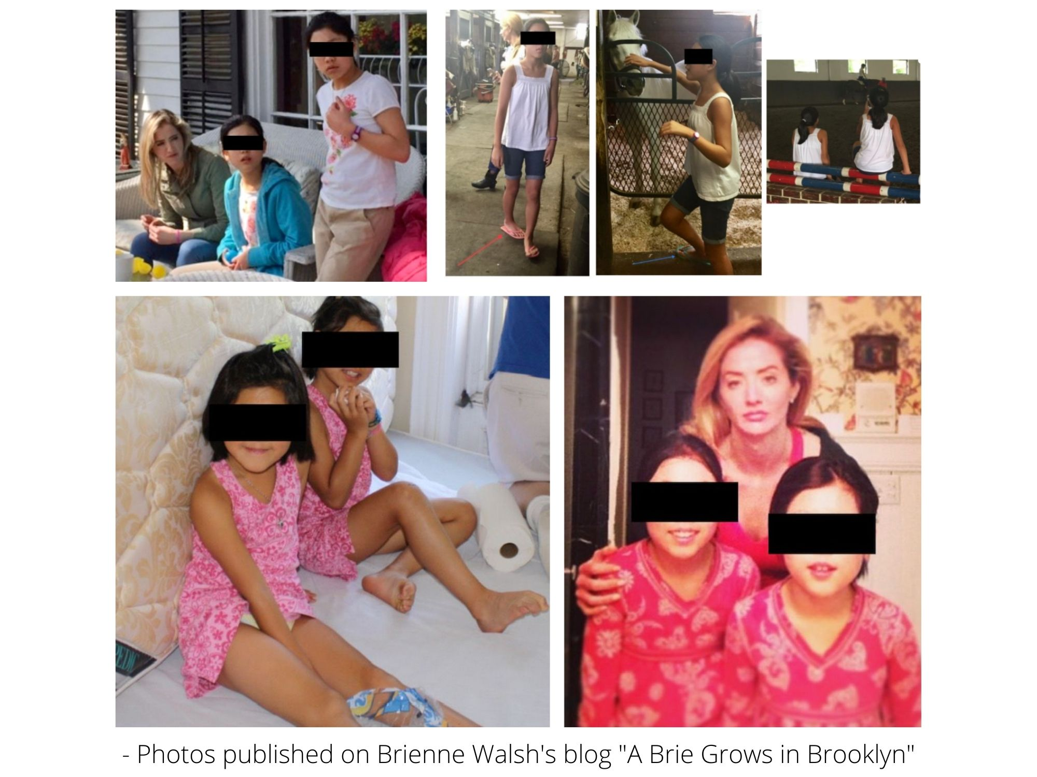

Brienne wrote that “the twins” responded to abuse at their home in much the same way that she and Tara had,

“They are not genetically the same as me, but their reactions to the abuse were identical. One reacts by being super good, and the other reacts by acting out, and they still get punished equally.” (Exhibit 17).

Tara Walsh texted me something similar shortly after returning to her childhood estate, “Kiara was having a breakdown – I can’t help but think my Mom gave bpd to 4/6 of us.” (Exhibit 18). In addition to emotional trauma and abuse, she alleges physical abuse as well.

“It’s honestly horrible living here – it's not healthy living here. I feel so sorry for my sisters. And they get into physical fights and stuff with my parents.” (Exhibit 19)

Most shockingly, at least one of the adopted daughters was diagnosed with the same hereditary disorder as the rest of the Walsh children by the ‘family’ Psychiatrist known for diagnosing everyone with Bipolar Disorder. (Exhibit 20) She stopped taking the heavy medication after experiencing negative side effects but later suspected Maura Walsh was ‘slipping’ the Lithium and Seroquel into her food when the negative reactions returned. She reached out to Tara for advice in May 2017. (Exhibit 21).

--------------------------------------------------------

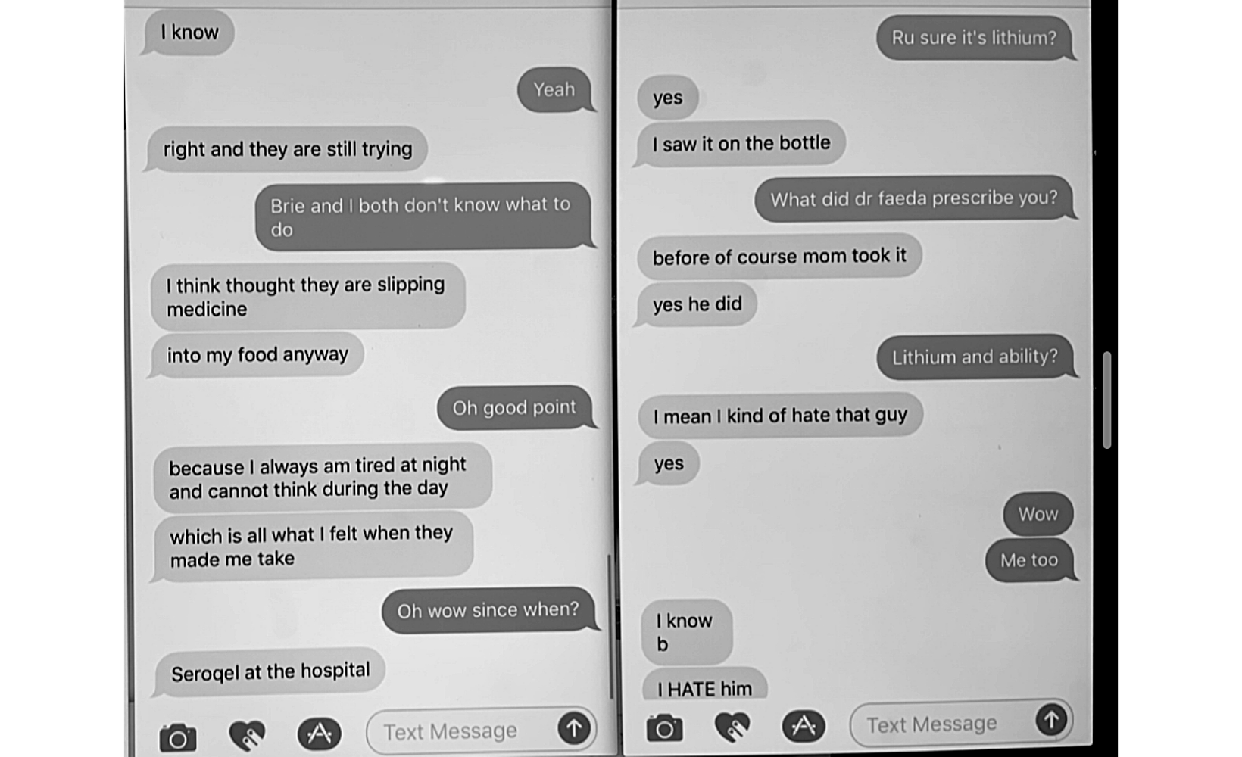

Adopted Daughter: “I think thought they are slipping medicine... into my food anyway... because I always am tired at night and cannot think during the day... which is all what I felt when they made me take it.”

Tara: “Oh wow since when?”

Adopted Daughter: “Seroquel at the hospital” […]

Tara: “Ru sure it’s lithium?”

Adopted Daughter: “Yes... I saw it on the bottle...before of course mom took it”
--------------------------------------------------------

Despite threats from Steve and Maura Walsh, the eldest adopted daughter, Mariah Walsh, recently fled the family home and moved to Savannah, GA to live with Brienne Walsh, her husband, and their two children. Brienne writes that a father of one of Mariah’s friends reached out to her, “saying he was worried about my sister and wondering if she could come and live with us. The same family also offered to help pay for [her] college bills.” (Exhibit 22)

Steve and Maura Walsh were not pleased, “Yesterday [she] told my parents that she was coming to live with me. Their response was that if she does that, she’ll be out on her own. They’ll cut off paying college tuition in the future, as well as her healthcare.” (Exhibit 22)

The Crime: Tara Walsh drugs me in the same manner her mother, Maura Walsh, secretly drugged her and her siblings.

Maura Walsh would advise her children not to have children, “given the history of mental illness in our family.” (Exhibit 23) For Tara, it was a bit different. They were concerned that her mental illness would cause her to lose custody and endanger the massive family trust. It is likely for these reasons that Tara became fixated on finding and marrying a wealthy man who she could entrap for his money but would ultimately just go away... She could be free of her parents and finally live her life financially secure.

In March 2017, my son, after undergoing months of tests while feeling ‘not like himself,’ a toxicology test showed over 6x times the reference range for Lithium – the same heavy mood stabilizer that Tara’s sister Kiara suspected Maura Walsh was ‘slipping’ into her food. (Exhibit 25). My son has never taken nor been prescribed Lithium and the doctors could not explain the results.

Over Tara’s subsequent pregnancy and while she lived with my son in San Francisco, he would repeatedly feel drugged. Emergency room tests did not show anything and doctors were dumbfounded until Evie’s nanny, Abby Tedla, caught Tara ‘slipping’ pills in my son’s wine in May 2018. Tara has since admitted, in open court under oath, to surreptitiously drugging my son with her anti-psychotic medication, Seroquel, (Exhibit 26).

A forensic psychiatrist in San Francisco recommended by Tara’s primary care physician diagnosed her with Borderline Personality Disorder, a diagnosis later confirmed by her long-term therapist. (Exhibit 27) He suspected that Tara would require supervision with Evie for around five years, with intensive treatment, to help with her genetic mental health issues as well as the damage caused by overmedication at a young age and abuse. My son was granted Emergency Custody. (Exhibit 28)

Tara rationalized drugging my son while testifying at the San Francisco Domestic Restraining Order Hearing by saying, “We were living as a family. I made a family decision.” (Exhibit 29)

It was also clear that my son had been targeted by Tara due to her perception of my sons ‘wealth.’ For example, she texted her friend just a week before moving to San Francisco, “I’m better off pretending I want to be with him and getting the most while I can – then leaving him for good... I think he will marry me... Then I can just divorce him for money.” (Exhibit 30). While in San Francisco she used Evie as leverage for marriage (Exhibit 31), then a fake pregnancy (Exhibit 32), and stole my sons hidden and private financial records to see ‘just how much he had.’ (Exhibit 33)

Tara’s scheme was an open secret in her family. Brienne blogged that Tara was, “scheming to get her baby daddy committed.” (Exhibit 34) Yet also casually discussed with their brother that Tara just wanted money “Yeah she called me last night to say the same thing – [she's] just with Steve to take his money and then she will leave. I get the impression that she is now planning to head back here and is greasing the skid so everyone is happy to see her.” (Exhibit 35)

Steve Walsh Arranges for Kidnapping of Evie

Tara Walsh initially attempted to flee WITHOUT Evie, fearing criminal prosecution but her father talked her into coming back home to San Francisco. (Exhibit 36)

Later she attempted to flee again, but with Evie this time and her father talked her into returning home again to San Francisco. (Exhibit 38)

At this point a Court Order prohibited Tara from leaving California with Evie. (Exhibit 39). Steve Walsh and I had been in regular contact about treatment and (Exhibit 40) he negotiated a ‘two week’ exception from the Court Order so that Evie could accompany Tara on her trip to NY. Tara would get help with her diagnosis and treatment options and Evie wouldn’t leave his sight. (Exhibit 40-41)

Unbeknownst to me, Steve Walsh had already hired a full-time nanny in Westchester, NY even though Tara had an apartment in Brooklyn pre-paid for the next six months and I was in San Francisco. (Exhibit 42). He later admitted in a sworn deposition that he never attempted to abide the court order.

When asked why he didn’t fly to San Francisco considering the severity of the situation he replied, “It’s a six hour flight and that is not something someone just does.” (Exhibit 44) In reality, he understood that Tara wasn’t able to care of Evie on her own and wanted to be Evie’s guardian. Meanwhile, my son and I have spent months in Westchester and flown across the country dozens of times for my daughter.

Since arriving in Westchester Tara has complained of abuse but has been silenced each time.

- “No they love Evie so much – my Mom doesn’t ever want her to leave. But I seriously cannot stand living here... It really hasn’t been that bad – it only gets bad when I say I want to leave” - Tara texts Linda Russell, June 2018 (Exhibit 46)

- “It’s honestly horrible living here – it's not healthy” - Tara texts Steve Russell, June 2018 (Exhibit 47-48)

- In July 2018, Tara sent a text to Linda Russell stating, “Steve sent an agreement today I could move back to Brooklyn. I told my family and now they have all joined up to say they will take legal action”

- Tara, the court-appointed supervisor, and I all reported suspicious bruises on Evie. (Exhibit 49). When the Walsh’s were asked about it, Tara changed her story and stated the bruises were normal, (Exhibit 50) she followed-up with an odd letter through her attorney stating that there were no bruises and no history of abuse at the Walsh household. Instead claiming that my following-up on the bruises that she, I, and the supervisor noted as suspicious, was harassment of her. (Exhibit 50). Visits were stopped.

Steve and Maura Walsh Are Instrumental in the Alienation of Evie from her Father

Tara continues to show single-mindedness about moving out of her parents’ home. For example, on November 12, 2020 Tara and her friend, Jesse Ozeri, proposed to my son that Tara, “want[ed] to move out of the Walsh house immediately.” Specifically, she dangled my son’s unrestricted access to Evie in exchange for his “help” leaving her parents’ compound, which included that my son buy Tara a home for her and Evie in Westchester or Greenwich, Connecticut. In return, Tara would allow my son to begin visitation with Evie in their new home, that he would buy for them as often as he wanted. In other words, Tara tried to extort my son to buy her new home if he wanted unlimited access to his daughter. Tara’s attempt to leverage my son could not have been clearer when she messaged him: “Sooner you get the house for Evie the sooner visits can start.” (Exhibit 60)

Earlier this year, after my son refused to go along with Tara’s pressure tactics, Tara filed an emergency support motion and made it clear she needed funds to move out of her parents’ estate ASAP. It was granted. Months later, however, we learned, and it is undisputed, that Tara is still living there. Thus, it was all a ruse.

Steve and Maura Walsh have been active participants in denying my relationship with my granddaughter, yet to the court they act as if they are not involved. However, that claim is belied by their words and actions. Steve Walsh became the gatekeeper for Evie as soon as she arrived at his compound. He immediately stopped facilitating communication once concerns about the allegations of abuse against his adopted daughters was brought to light.

Maura Walsh aided her husband’s effort to keep me from seeing Evie. On March 28, 2019, she took Evie to the doctor and claimed she was having terrible diarrhea 5x per day, but her doctor found no signs of diarrhea, fever, poor mood, or dehydration. The doctor diagnosed a possible intestinal infection in the absence of any measurable symptoms based solely on the statement of Maura Walsh. Now knowing Maura Walsh’s history of medical child abuse this is more concerning.

The Walshes refused to explicitly confirm my visits with Evie placing me in a precarious position that they exploited.

More recently, Steve Walsh sent an email to my attorney claiming that Evie suffered hives as a result of stress during her visit with me, effectively stopping the visits. There was no doctor’s note or opinion on the matter. Linda actually gets a similar rash on her cheeks as well after eating strawberries and had contacted Tara to check about applying a topical over-the-counter cream that helps the itching. This was yet another Walsh family tactic to prevent me from visiting Evie.

My son reported the bruises to Attorney for the Child (“AFC”), Jennifer Jackman, that same day as well as to my attorneys. (Exhibit 53). Importantly, Ms. Walsh also apparently noted the bruises that day, and independently contacted Ms. Jackman to express concerns about them— which were substantial enough that she, as the primary custodial parent, felt the need to contact the AFC.
All of my visitations had been fully supervised at that point so there was no possibility that the bruises were caused by me. On the other hand, the Walsh family, with its long history of physical abuse, and who are presently Evie’s sole, unsupervised custodians, must have necessarily inflicted the bruises.

Additionally, and most recently, Steve and Maura Walsh have at every turn attempted to obstruct my visitation with Evie through repeated denial of visits, making false statements to Evie to deliberately alienate me from my granddaughter, and making false representations regarding visitation to this Court. Most recently, Steve Walsh manufactured false representations to the Court that Evie had hives in response to stress due to visits with me. However, I am a licensed nurse— and I confirmed that Evie had an adverse reaction to strawberries that the Walshes themselves had packed for her. Notably, when asked for additional details on my granddaughters symptoms, the Walshe’s could not provide any support for their false claims. This is just another example of the pattern of lies and abuse by the Walsh family.

Conclusion
To put it plainly, I fear that my granddaughter is in imminent danger. Her sole custodians, the Walsh family, have a long, sordid history of abuse and dysfunction. Ms. Walsh suffers from serious mental illness and relies significantly on her family’s assistance for childcare. However, her family is not capable of providing a safe, healthy environment for Evie. Ms. Walsh and Evie were mandated to her parents’ home for the apparent support network she would have there. But it is now painfully evident that the Walsh residence is too volatile and dangerous to leave Evie in without outside supervision. Evidence of abuse and neglect comes directly from Walsh family members themselves and should therefore be believed.

The Court was plainly lied to in order to obfuscate the Walshes abusive and dysfunctional living arrangement. We recently learned that Tara was still living at her parents’ home despite having asked for and been granted by the support court, a large sum to move out.

The Walsh family has made allegation after allegation against my son and none have been proven or even followed-up on. Meanwhile Steve and Maura Walsh have been sued in the past for custody of their children over allegations of abuse, two of their children have fled their home, sworn testimony from Tara’s sibling confirmed her childhood was abusive, and they are actively alienating me from my daughter.

WHEREFORE, I respectfully request that the Court:

  - immediately remove Evie from the Walsh household and place Evie with me, Evie’s paternal grandmother, who can oversee and facilitate visits with Tara;
  - order prohibiting Evie’s maternal grandparents from all unsupervised contact with Evie until CPS can conduct a review of the abuse allegations, including access to Tara’s previous emancipation case.
  - order the release of Evie’s medical records and for a doctor to check on her rash / allergies;
  - schedule an immediate trial of the issues raised in this case.

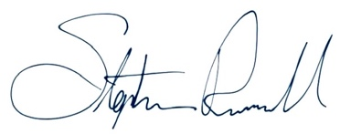
Dated: October 1, 2021

________________________________
Stephen Grant Russell

